TESTS RUN ON THE INTERNATIONAL STUDENT WEBSITE


FIRST TEST: Functional testing.
Actions:
- Complete the registration format by filling all the information required.
- Entering a password in the field: “Confirming password” that doesn’t match the field “password” to see what happens.
Result:
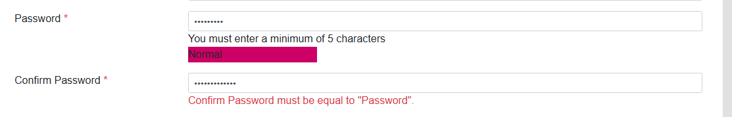
Conclusion: It doesn’t allow to complete the student registration because of the different passwords entered. The application behaves as expected when the user enters different passwords.

SECOND TEST: Responsive design testing.
Actions:
- Enter in DevTools, press Ctrl + Shift + M.
- Change the dimensions of the browser viewport to 200 pixels.
Result:
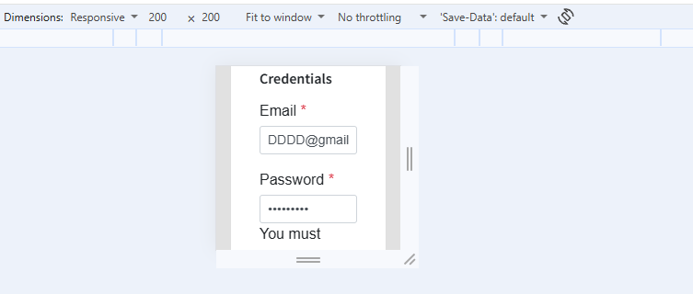

Conclusion:
Even in low dimensions, the application still shows all the fields required to fill and complete the registration. The application behaves as expected when testing and changing the browser viewport dimensions.

THIRD TEST: Negative/error handling test.
Actions:
- Enter in the sign-up section.
- Enter a username and a password that are not registered in the application.
Result:
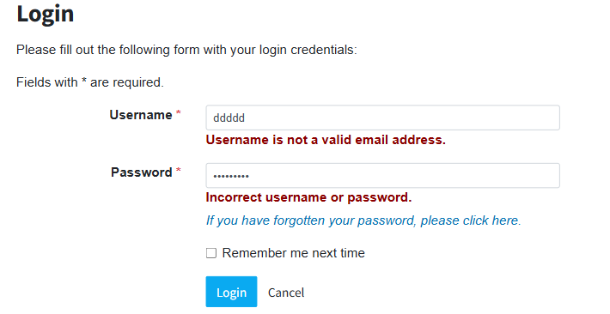
Conclusion: The application system works well by recognizing that the data I entered has not yet been recorded in the application's database.
FOURTH TEST: Regression test.

Actions:
- Re-enter passwords that don’t match in the registration fields.
- Change again the browser viewport to 200 pixels.
- Enter incorrect data in the sign in option.
Results:
1.
2.
3.
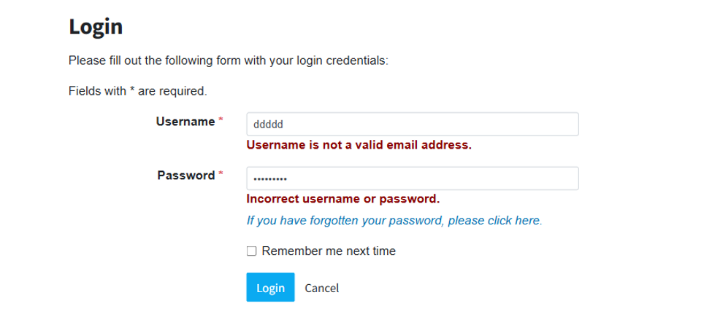
Conclusion: The application continues showing that it behaves properly in all of the three tests I run.

FIFTH TEST: Usability test.

Actions:
- Invite a user who is interested in registering.
- Tell them to try all the application features.
- Ask them if the platform is user friendly and easy to use.

Result: The user tells me that the interface is easy to understand and navigate. According to him, the application meets all the requirements necessary to successfully complete the registration.

Conclusion: The application is behaving perfectly due to its easy accessibility and intuitive system.

